Write a program for A* (A-Star) search algorithm using python code

Aim :To implement the A* (A-Star) search algorithm using Python.
Procedure:
Define the graph with edge costs.
Define the heuristic values for each node.
Start from the source node.
Select the node with the lowest f(n) = g(n) + h(n).
Continue until the goal node is reached.
Display the shortest path.

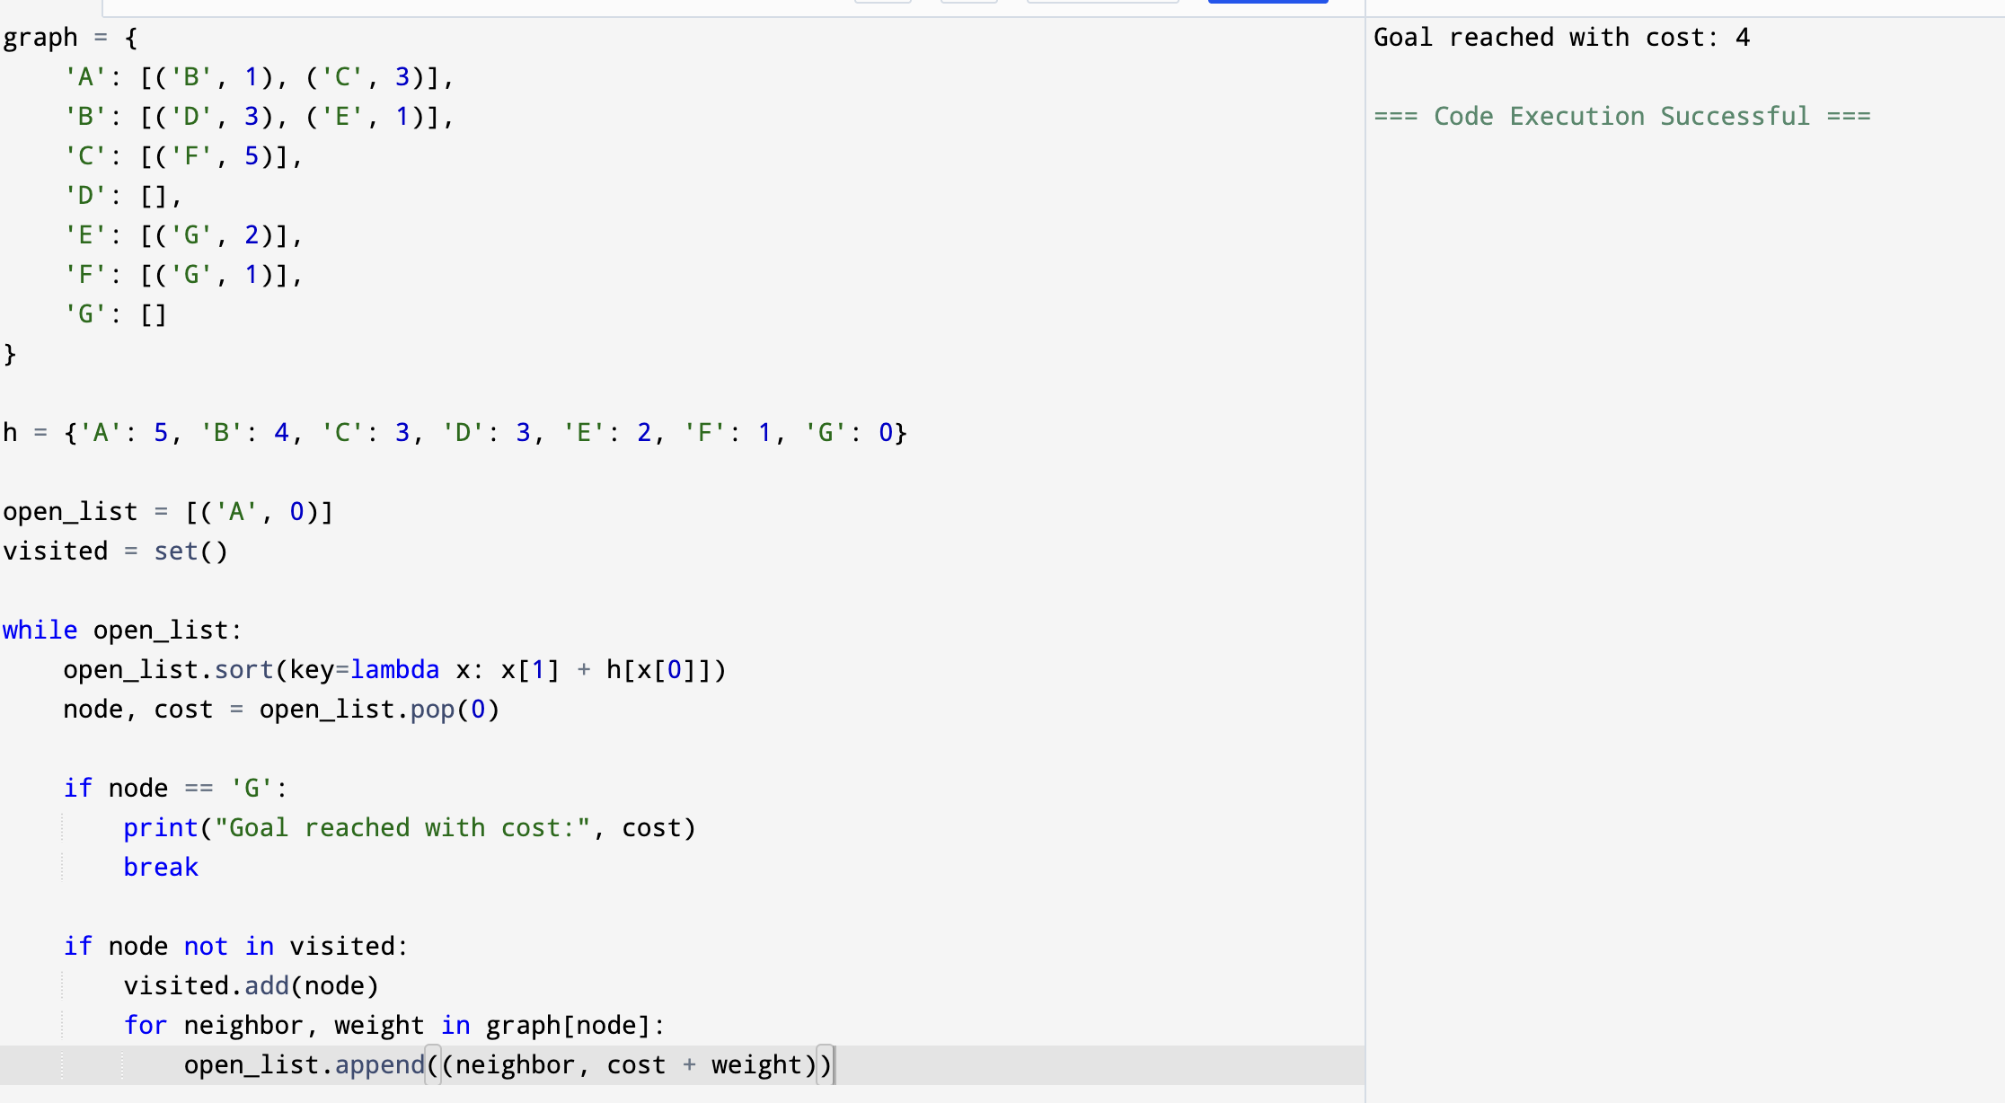
Output:

Result: Hence, A* (A-Star) search algorithm has solved

